MEET BARRY LEVINE
Author of
Yankee Air Museum (2018) and Michigan Aviation: People and Places that Changed History (2021)
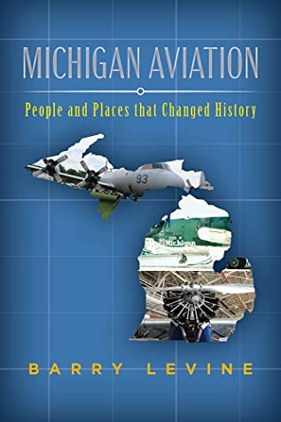
Thursday, December 2, 2021 @ 6:00 pm
This event will be held in the Activity Room at the
Flat Rock Public Library.
Refreshments will be served.
There is limited seating, so don’t be late!

